Contents

**Study Reflection: Unit SIT120 Introduction to Responsive Web Apps** 2

Week 1: Introduction HTML and CSS 2

Reflection 2

1. Typical of HTML structure 2

2. HTML, CSS, JavaScript for calculating numbers, creating form and hyperlink 5

3. How to organise the codes on Visual Studio 6

**Week 2: Responsive web apps design, advanced HTML, CSS and JavaScript** 7

Reflection & github link 7

1. Analysis the responsive website 7

2. Learning how to use Figma for design 9

3. User Stories 9

4. Practising HTML, CSS on w3school.com 11

5. Use graphics, media, API’s 12

Week 3: Practicing JavaScript Functions 13

Reflection & github link 13

1. Task Length Property 13

2. Task JavaScript Number and Array Methods 13

3. Task JavaScript Get/Set Methods 14

Week 4: Vue.js Framework 15

Reflection & github link 15

1. Task Declarative rendering 15

2. Task Conditionals and loops 16

3. I learned how to install Vue.js 16

Week 5: Vue.js Framework 18

Reflection 18

Learn Composing with Components 18

Week 6: Vue.js Framework (Handling User Inputs) 19

Reflection & github link 19

1. Applying form input binding on the project 19

2. Task Using V-model for handling user inputs 21

3. Task Checkbox subjects that I have learned so far 22

4. Task Dynamic options rendering v-for 23

5. Task Using Modifiers (Lazy, Trim, Number) 23

Week 7: Vue.js Framework (Handling User Inputs) 24

Reflection & github link 24

1. Applying form input binding on the project 25

Project Progress 25

# **Study Reflection: Unit SIT120 Introduction to Responsive Web Apps**

With my current situation, I aim to get “credit” mark, if I could achieve “distinction” is a big bonus. However, I really want to learn and understand a lot on this unit, because this is what I am looking for my future job.

I have been feeling anxious recently. I lost 1 elder sister from unknown death and 1 younger sister from Covid-19 in about 4,5 months. After that, my mom and 3 youngest sisters were unwell due to Covid-19 in Indonesia. It has been very tough, and I have 11 months old Charlie which is very active now. I have missed study in week 1-3 and started study in week 4. However, I been managing to catch up.

# Week 1: Introduction HTML and CSS

## Reflection

I studied basic HTML in other unit previously, so it has been good foundation in this unit, SIT120 Introduction Responsive Website Apps and I have learned a lot of HTML and CSS on [W3School](https://www.w3schools.com/). However, here are important points in HTML and CSS.

What is a web application?

A web application is a software which make web reachable from any web browser, and the software typically using language like HTML, CSS, and JavaScript. I have understood how they work together after practising and using them on the project proposal. Below are some basic knowledges about CSS, HTML and JavaScript.

## Typical of HTML structure

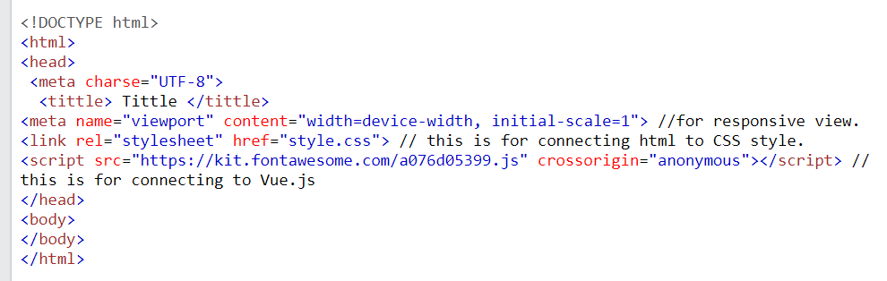

Figure 1 HTML Structure

<head> is the first section in the code containing information about a web page's properties and links to external related files. For example, in the HTML head, you can have the tittle of the page, meta tags, CSS code, Open Graph tags, and JavaScript code.

<h1> is an HTML tag that indicates a heading on a website and defines the most important heading.

Below is the level of header *(at Figure 2*).

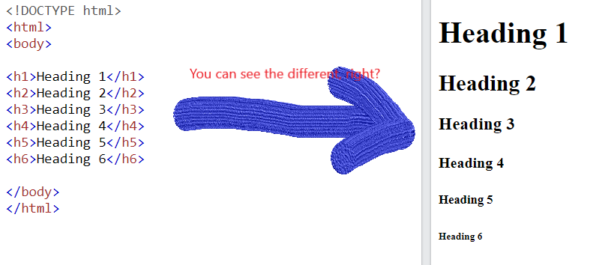

Figure 2 Level of Heading

Below is an example of paragraph (<p>) inside HTML <body> with header <h2> at *Figure 3*.

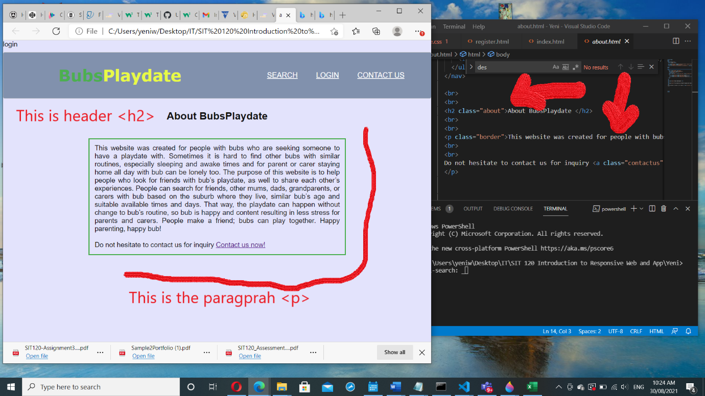

Figure 3 The Header

The component of box is important knowledge in CSS, Below are the examples before and after using CSS style. You will see the different on *Figure 5 and 6*.

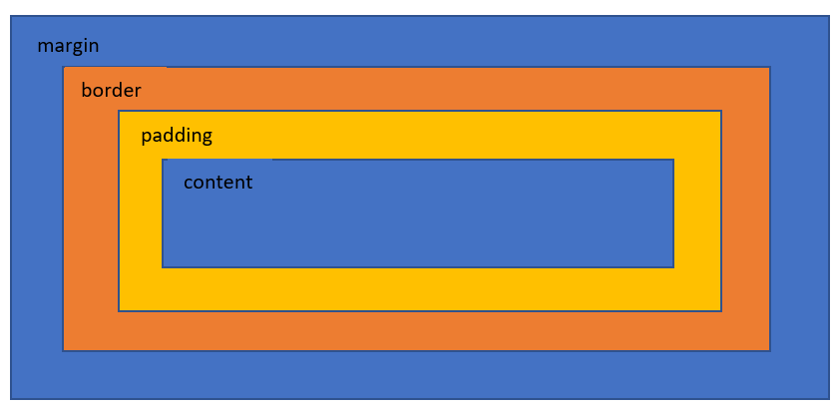

Figure 4 Box's Component

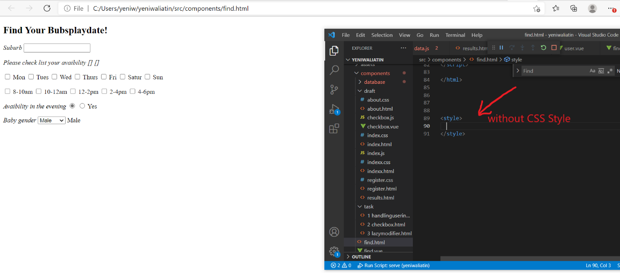

Figure 5 Margin without CSS style

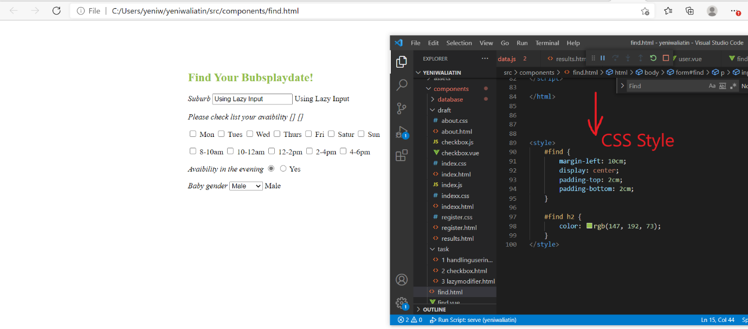

Figure 6 Margin in CSS style

## HTML, CSS, JavaScript for calculating numbers, creating form and hyperlink

The code is in Github: [SIT120/Prac1.html at main · ywaliatin/SIT120 (github.com)](https://github.com/ywaliatin/SIT120/blob/main/Prac1.html)

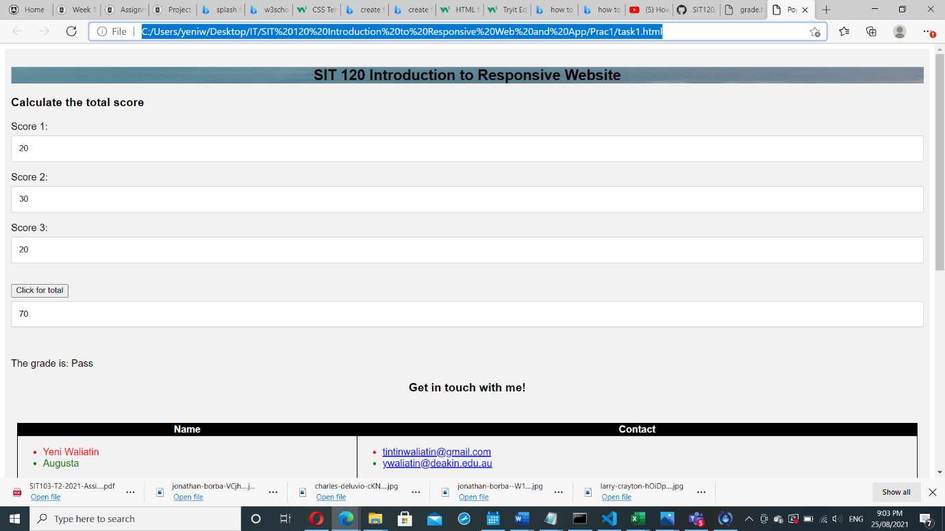

Figure 7 Task using HTML, CSS, JavaScript

Below is for creating text/ hyperlink in different colours which using <span> to block the text that I would like to put colour on *(Figure 8).*

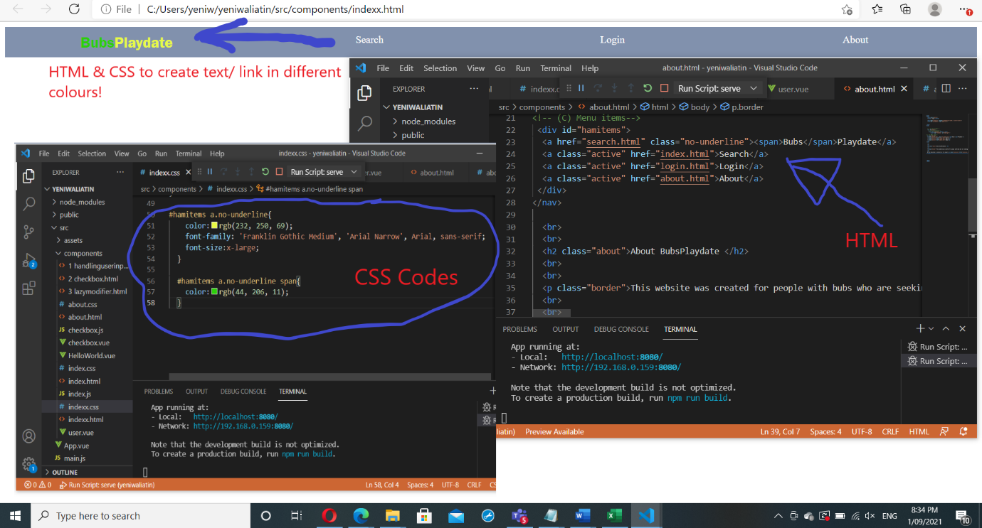

Figure 8 Colour in CSS style

## How to organise the codes on Visual Studio

First thing first, block all the codes by clicking Ctrl + A. Then, clicking Ctrl + K + F on your keyboard.

## How to write CSS code

See on *Figure 9* for the explanation and example.

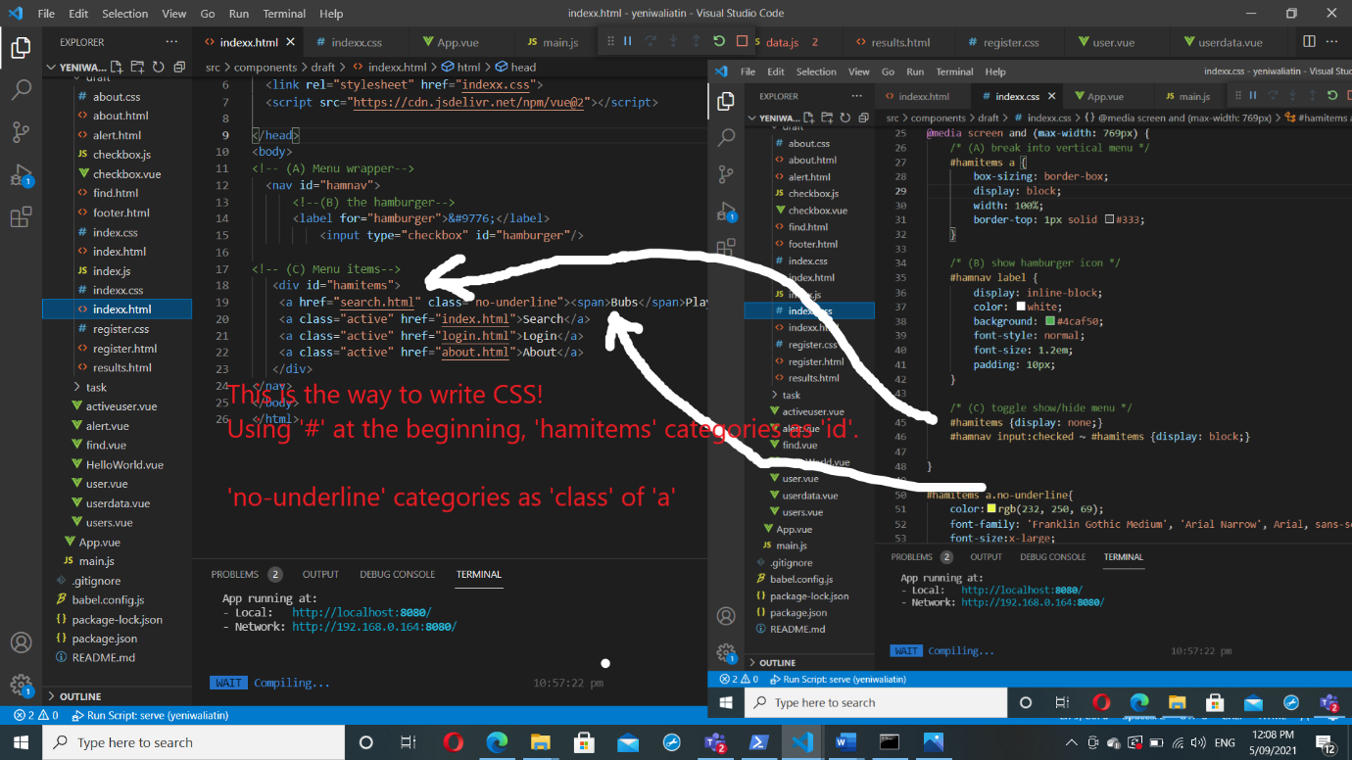

Figure How to write CSS

# **Week 2: Responsive web apps design, advanced HTML, CSS and JavaScript**

## Reflection & github link

I learned by using viewport value on HTML code, allows the page for becoming responsive in any width screen of devices, and learned many useful values on [this link](https://web.dev/responsive-web-design-basics/) about [responsive web design](https://web.dev/responsive-web-design-basics/).

This is the link on Github: [SIT120/Week4 at main · ywaliatin/SIT120 (github.com)](https://github.com/ywaliatin/SIT120/tree/main/Week4)

## Analysis the responsive website

This website is simple, clear, responsive, and easy to navigate. I would like to implement the web style on my project. Even though, the user accesses the website from mobile, the website components haven’t change and adjust the screen size accordingly

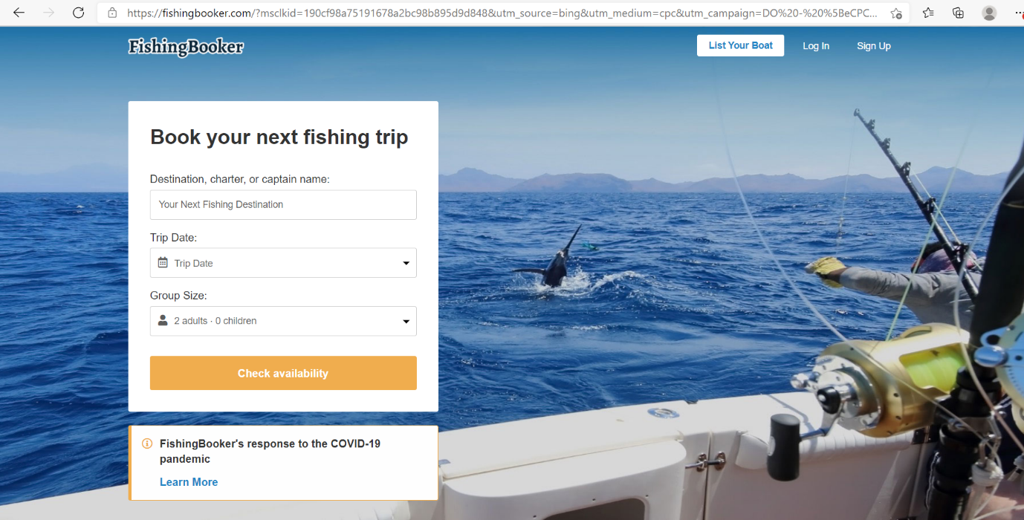

Figure 10 The web on desktop view

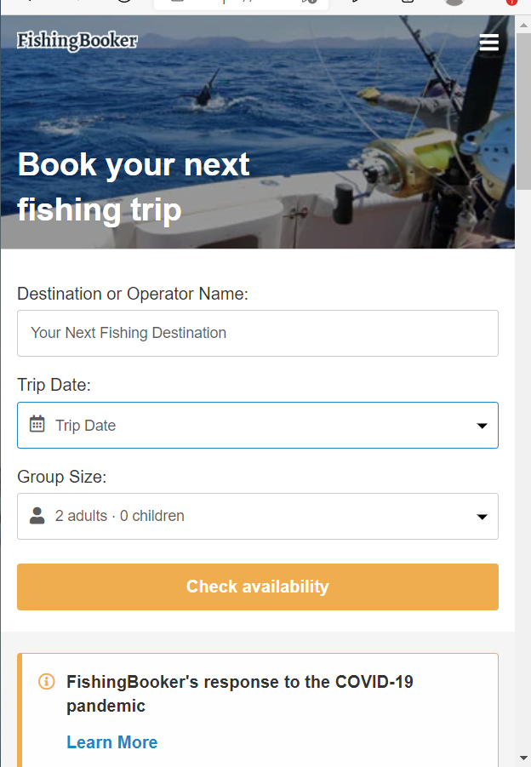

Figure 11 The web on mobile (responsive) view

My responsive website.

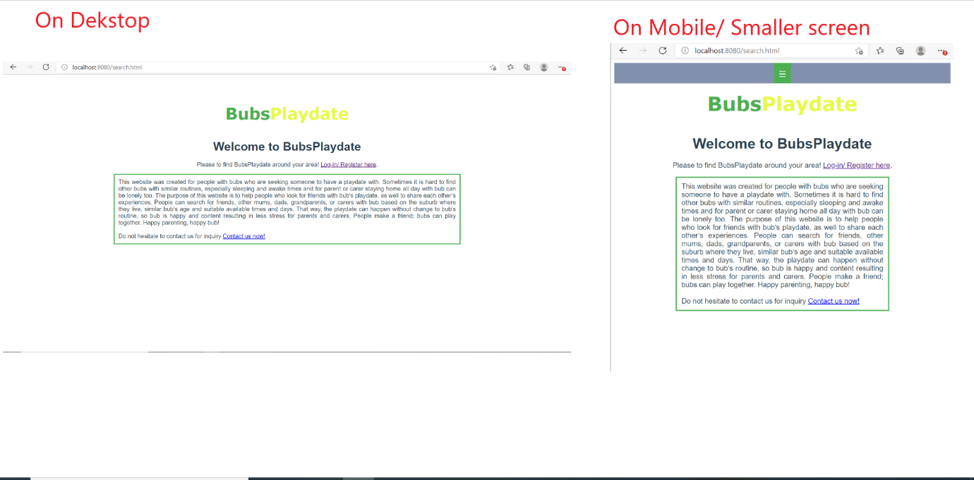

Figure Example responsive web

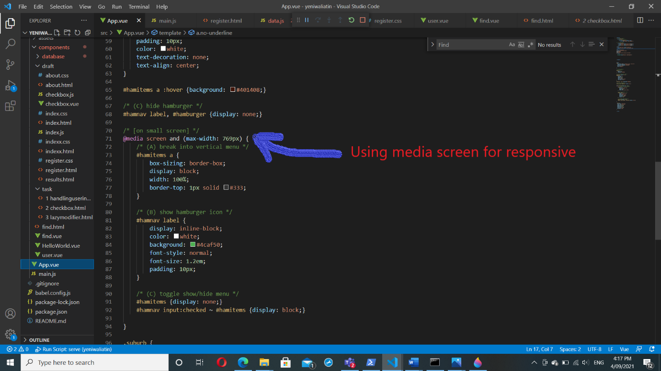

Figure CSS media screen for responsive web

## Learning how to use Figma for design

I learned how to design the website before building it by using Figma.

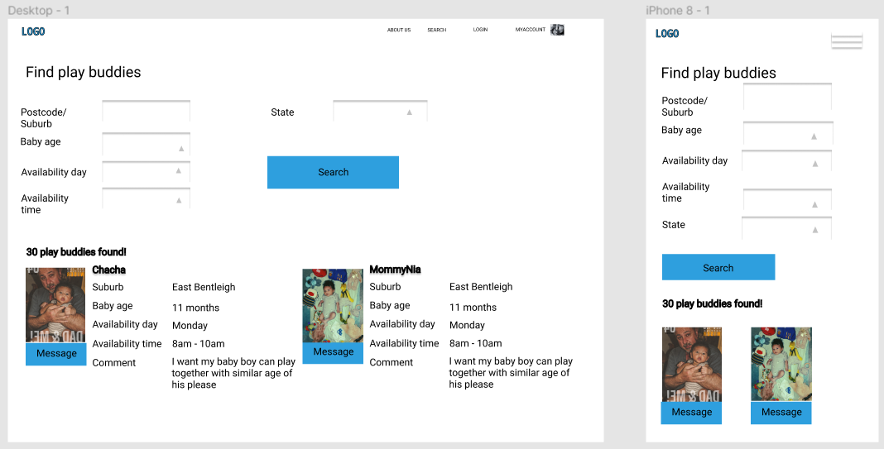

Figure Figma

## User Stories

**Case: 1**

|  |  |
| --- | --- |
| **Desire** | **Detail** |
| I can find other users with bubs, so we can organise a playdate together based on baby age, routine and my availability day and time within the area. | 1. On search page, the user can find other users 2. User can see the result based on filtering input on search page 3. User can use search filtering options such as suburb/ postcode, state, baby age, availability day and time |

**Case: 2**

|  |  |
| --- | --- |
| **Desire** | **Detail** |
| I wish to show my profile on search page list so that other users can see my profile. | 1. User’s profile must show on search page list when other users find by filtering input options 2. User can be found based on their profile criteria |

**Case: 3**

|  |  |
| --- | --- |
| **Desire** | **Detail** |
| I can specify my profile so that other users would be able to see my specific profile information. | 1. User can edit their profile, as well as user comment/ note 2. User should upload their profile picture so other user can see what they look like 3. Users can choose which information they would like to show on web page |

**Case: 4**

|  |  |
| --- | --- |
| **Desire** | **Detail** |
| I wish, I can send messages to other users that I interested-in so that I can talk with them to arrange the playdate. | 1. User can send messages to other users in a message box 2. User can receive messages in a message box 3. The notification for users if received any message from other users |

**Case: 5**

|  |  |
| --- | --- |
| **Desire** | **Detail** |
| I want to access this site from mobile device with same service without hassles. | 1. The website should be responsive for any other devices. 2. Button and menu options must be responsive |

**UX/UI Design**

I am going to use colours as below.



**Detail**

I am going to use colours as detail below. However, I would not rule out if there will be extra colours or slightly different colours and some other improvements on the final project.

* Black (#0f0f0f) or white: text
* Grey: menu bar background, button menu
* Light purple (RGB (227, 227, 252)): body background
* Green (#4CAF50) and yellow (RGB (232, 250, 69)): in logo, hover button

## Practising HTML, CSS on [w3school.com](http://www.w3school.com/)

It helps me a lot, especially how to use CSS style commands for each element such as use tag <span>, page layout, colour, image, content and more. All codes are available on [Github link](https://github.com/ywaliatin/SIT120/tree/main/Week4).

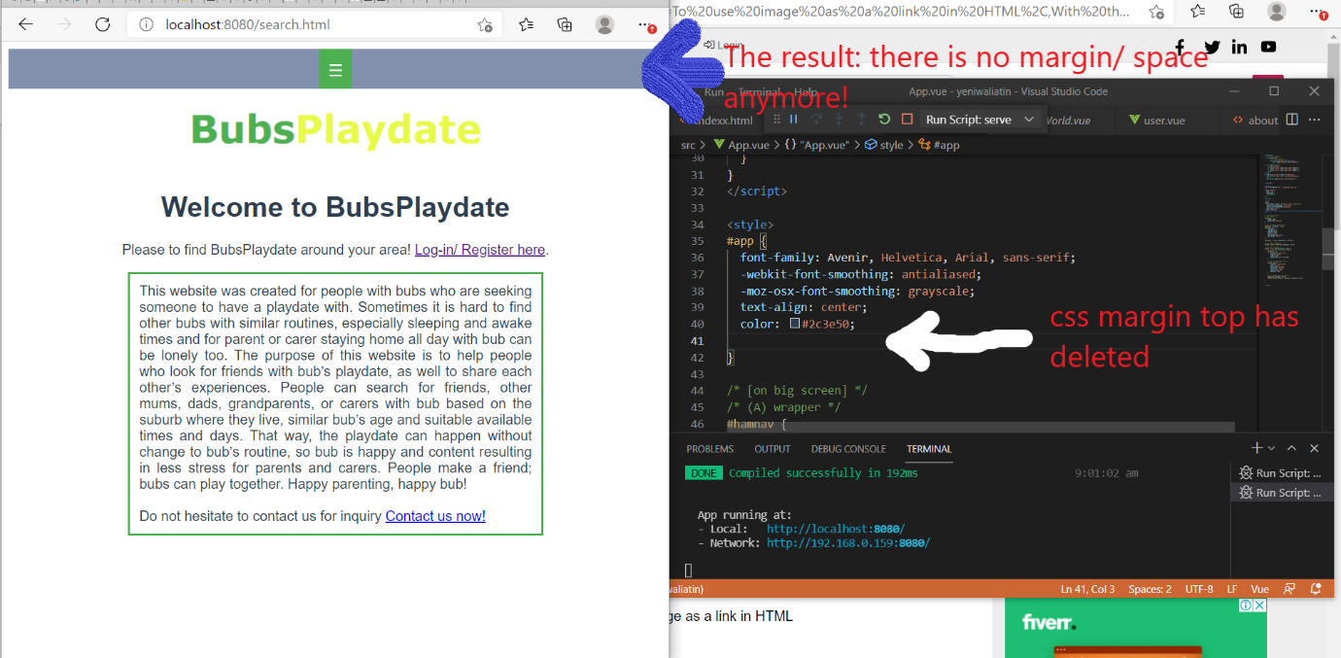

Figure HTML CSS

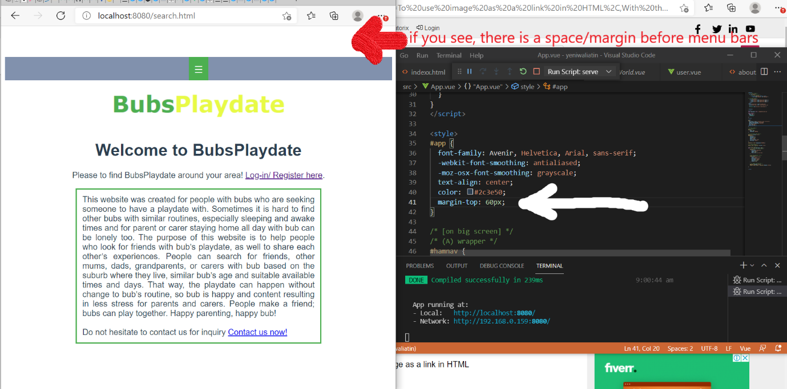

Figure HTML CSS

## Use graphics, media, API’s

Below is an example the inline frame element, see *Figure 14.*

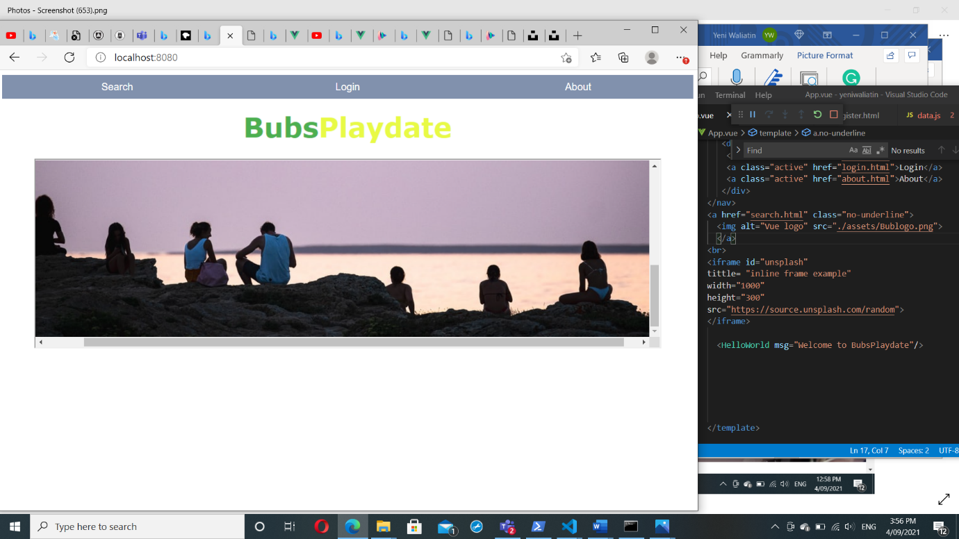

Figure iframe

# Week 3: Practicing JavaScript Functions

## Reflection & github link

Honestly, I do not have any knowledges about JavaScript. However, I have started to learn on this week through practical tasks, how JavaScript works and use [W3School web](https://www.w3schools.com/) as the guidelines.

This is the link on Github: [SIT120/Week4 at main · ywaliatin/SIT120 (github.com)](https://github.com/ywaliatin/SIT120/tree/main/Week4)

## Task Length Property

I learned “space bar is calculated as a length”.

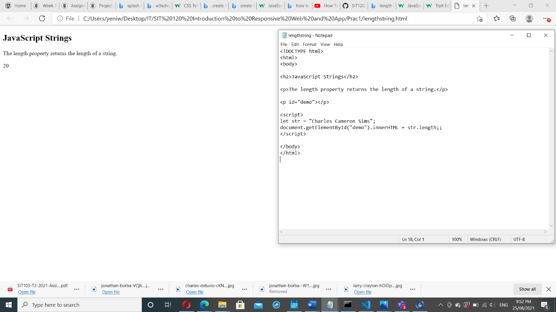

Figure Length Property (JavaScript)

## Task JavaScript Number and Array Methods

I have read, learned, and practised on [W3School website](https://www.w3schools.com/) such as one of this to use ‘join’ to combine array elements into a string.

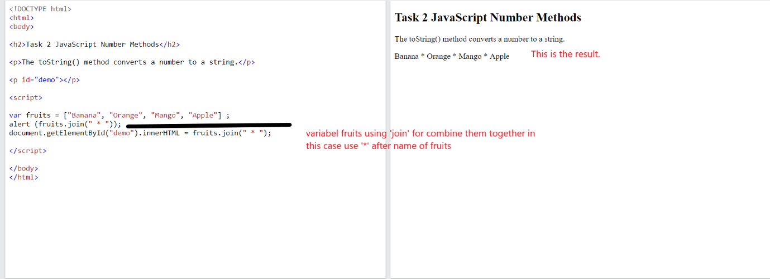

Figure JavaScript number & array method

## Task JavaScript Get/Set Methods

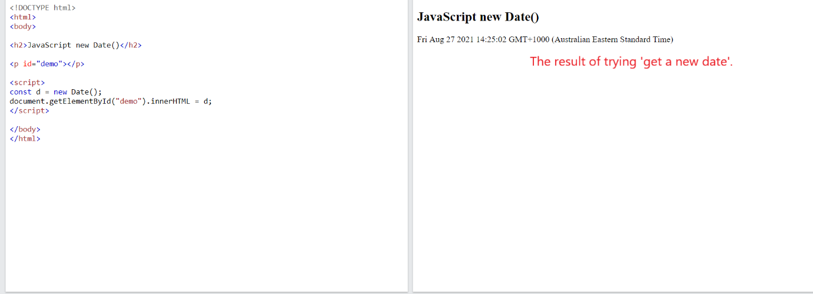

Figure JavaScript get/ set method

# Week 4: Vue.js Framework

## Reflection & github link

In this week, I installed Vue.js and created Vue project, learned rendering on this link: [Rendering](https://vuejs.org/v2/guide/#Declarative-Rendering), and practised for my first Vue.js.

This is the link on github: [SIT120/Week4 at main · ywaliatin/SIT120 (github.com)](https://github.com/ywaliatin/SIT120/tree/main/Week4)

## Task Declarative rendering

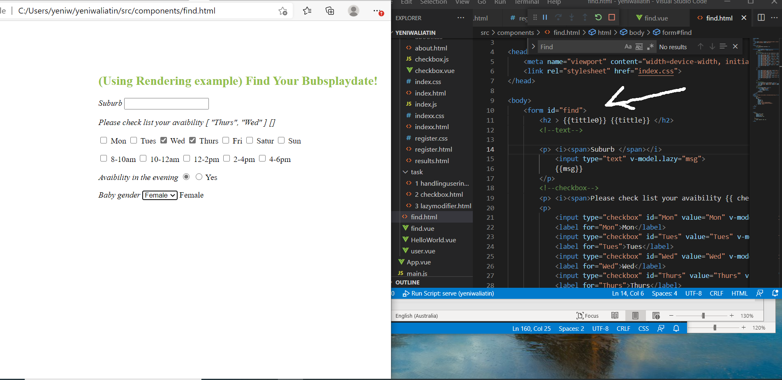

Figure Rendering

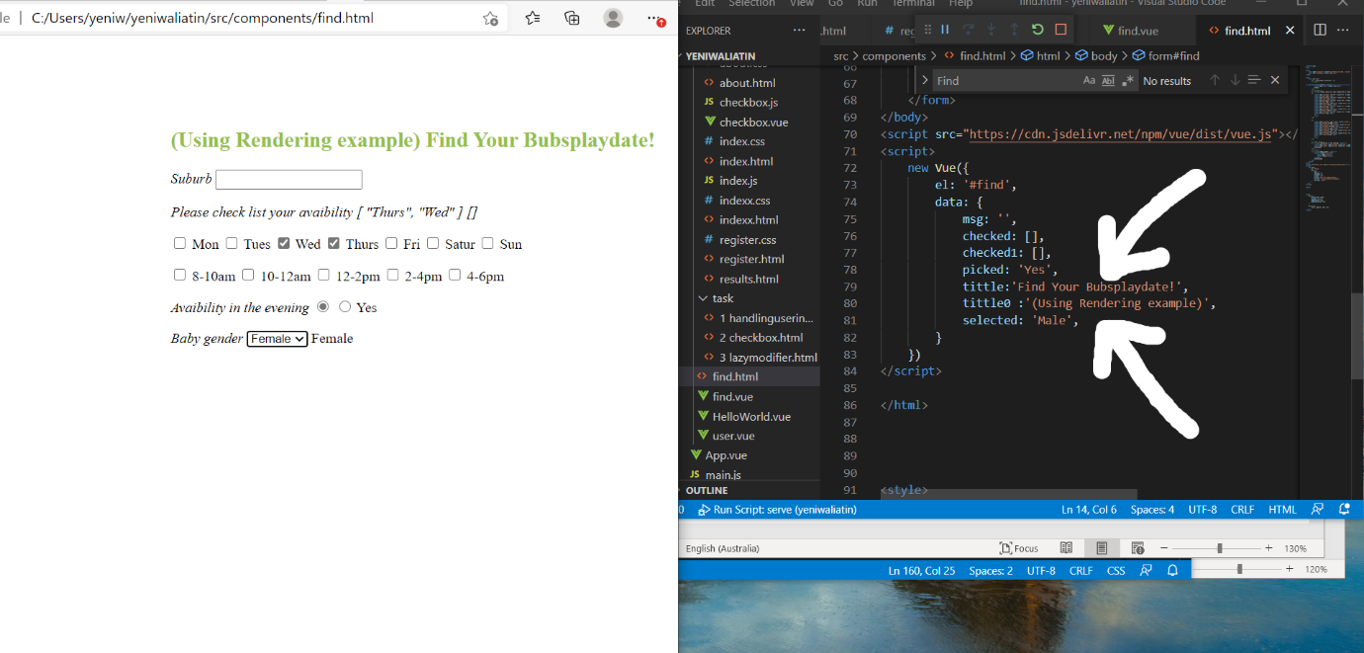

Figure Rendering

## Task Conditionals and loops

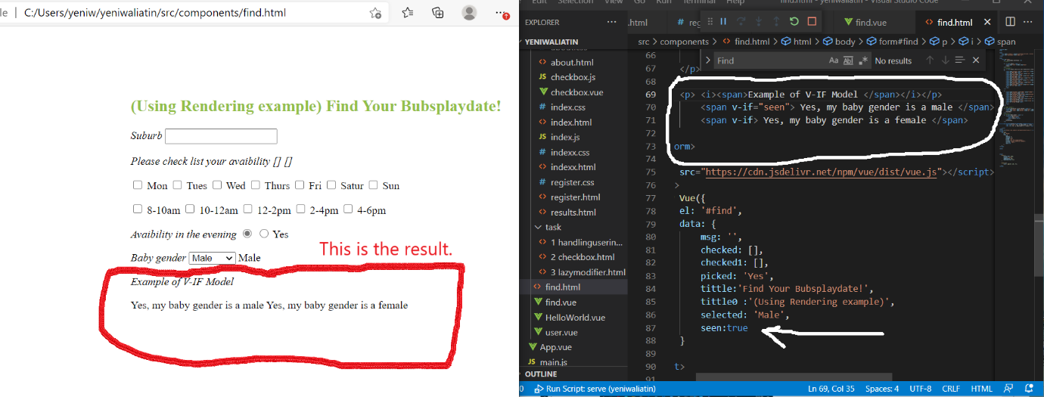

Figure Conditionals & loops

## I learned how to install Vue.js

I learned how to install Vue.js from this link YouTube [Install Vue.js](https://www.youtube.com/watch?v=isUih1dMXs8&t=94s) and installed Vue.js on my laptop. Screenshot below. First thing first, I installed [Nodejs](https://nodejs.org/en/), then simply following the instructions for next steps.

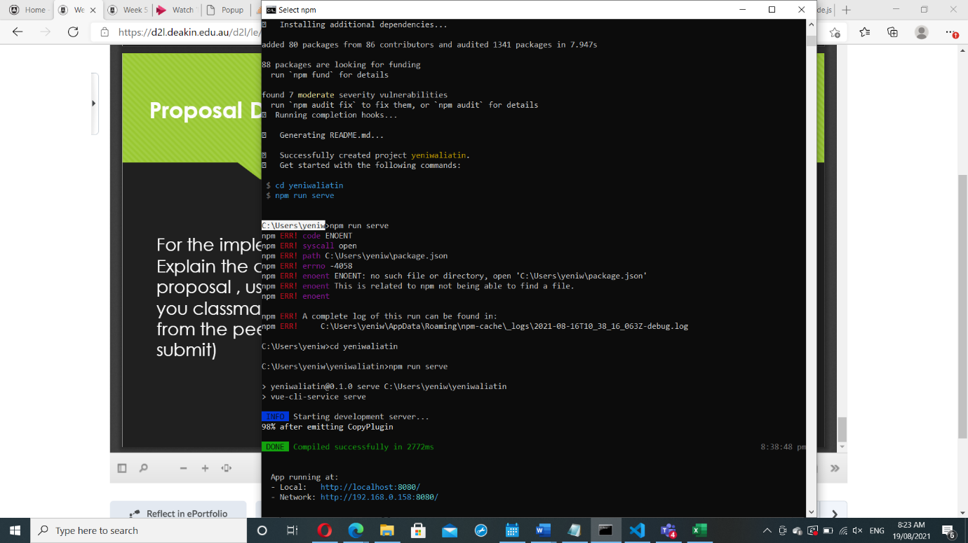

Figure Installing Vue

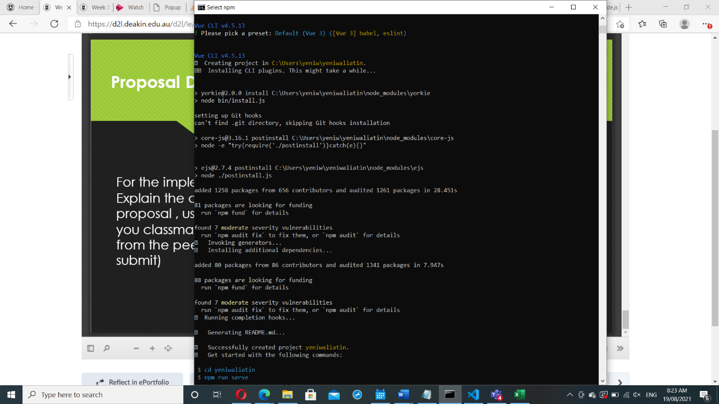

Figure Installing Vue

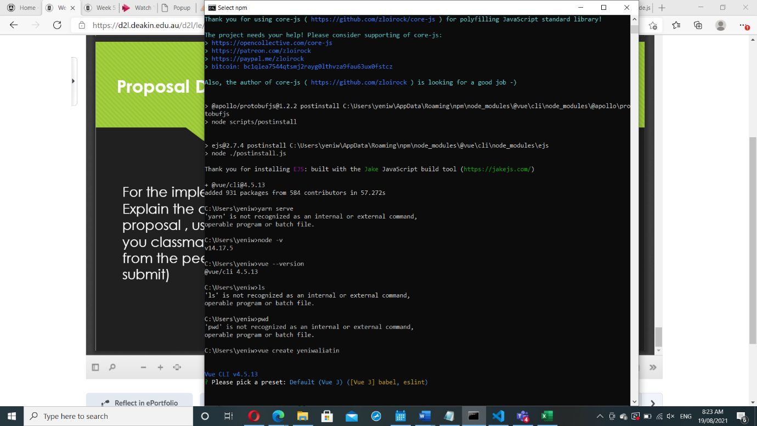

Figure Installing Vue

My first Vue project, screenshot as seen at *Figure 25*. For more detail and reference, you can see on [this link](https://www.blog.duomly.com/vue-js-tutorial-how-to-create-vue-js-app-in-5-minutes/).

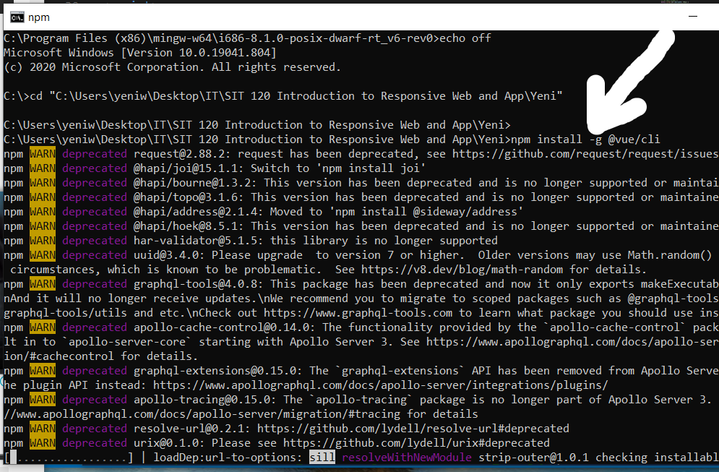

Figure Creating Vue project

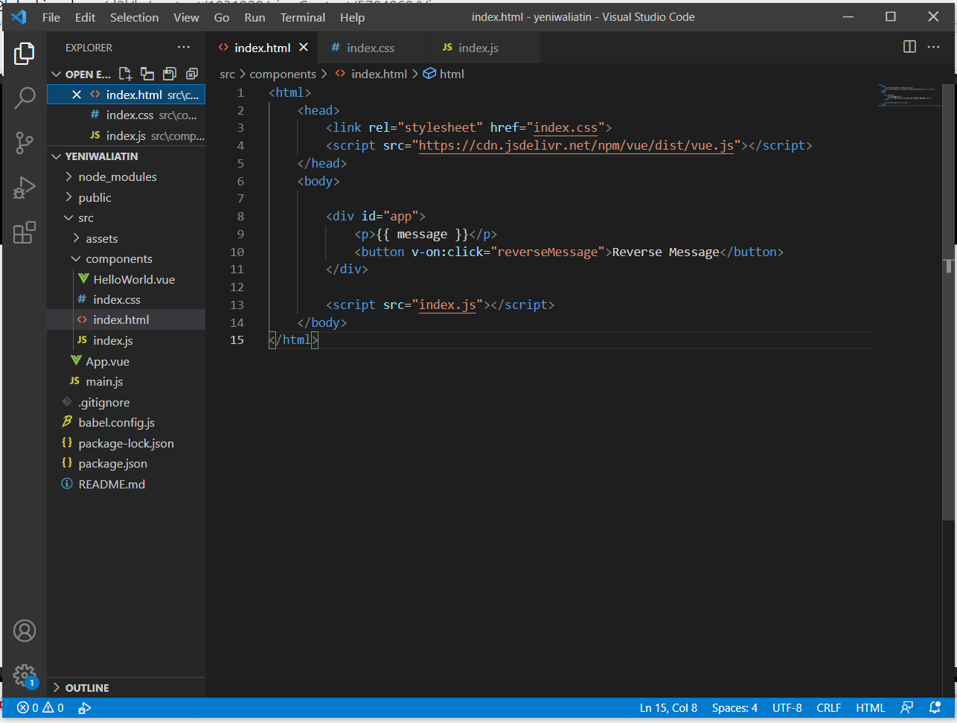

Figure Vue project

# Week 5: Vue.js Framework

## Reflection

In this week, I have learned about composing with components and explored more [Vue.js](https://vuejs.org/v2/guide/components.html). I have been also improved the project proposal and been practising in how HTML, CSS, JavaScript and Vue work together.

## Learn Composing with Components

For more detail about basic components, I have read on [Vue.js website](https://vuejs.org/v2/guide/components.html).

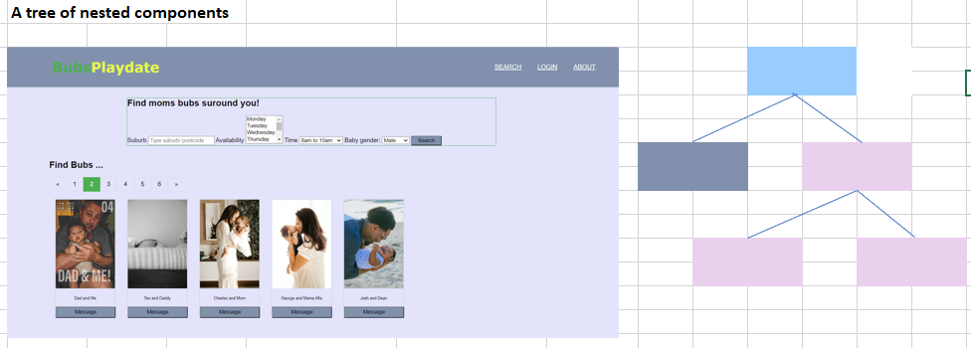

Figure Vue components

# Week 6: Vue.js Framework (Handling User Inputs)

## Reflection & github link

I have learned more about [Vue.js framework](https://vuejs.org/v2/guide/forms.html), how to use and apply handling user input, form input bindings, lazy, trim and number modifier also other components which they are so useful for my project, and I have more understanding how HTML, CSS, JavaScript and Vue work together.

Github link: [SIT120/Week6 at main · ywaliatin/SIT120 (github.com)](https://github.com/ywaliatin/SIT120/tree/main/Week6)

## Applying form input binding on the project

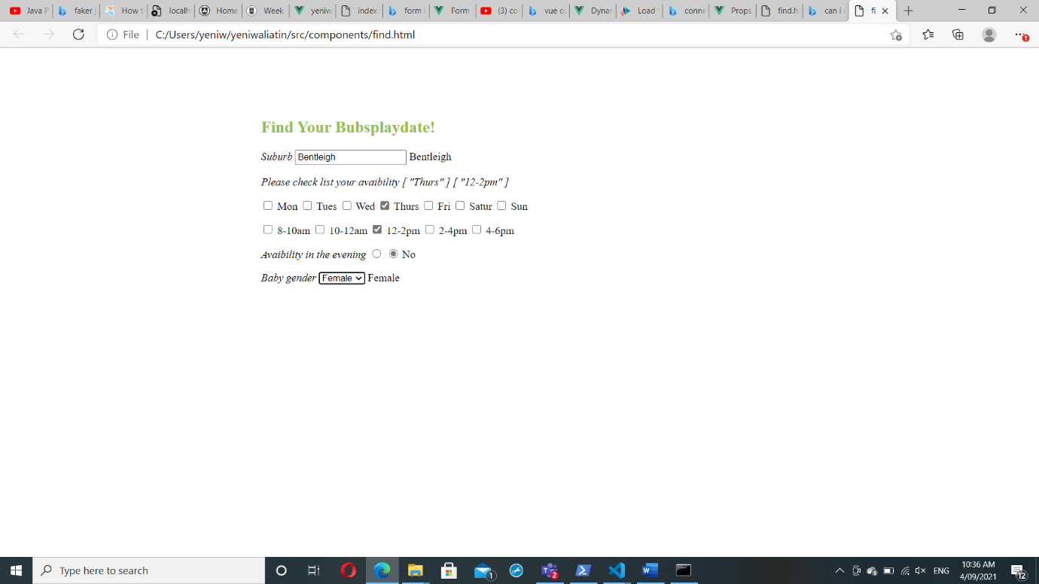

Figure Form input binding

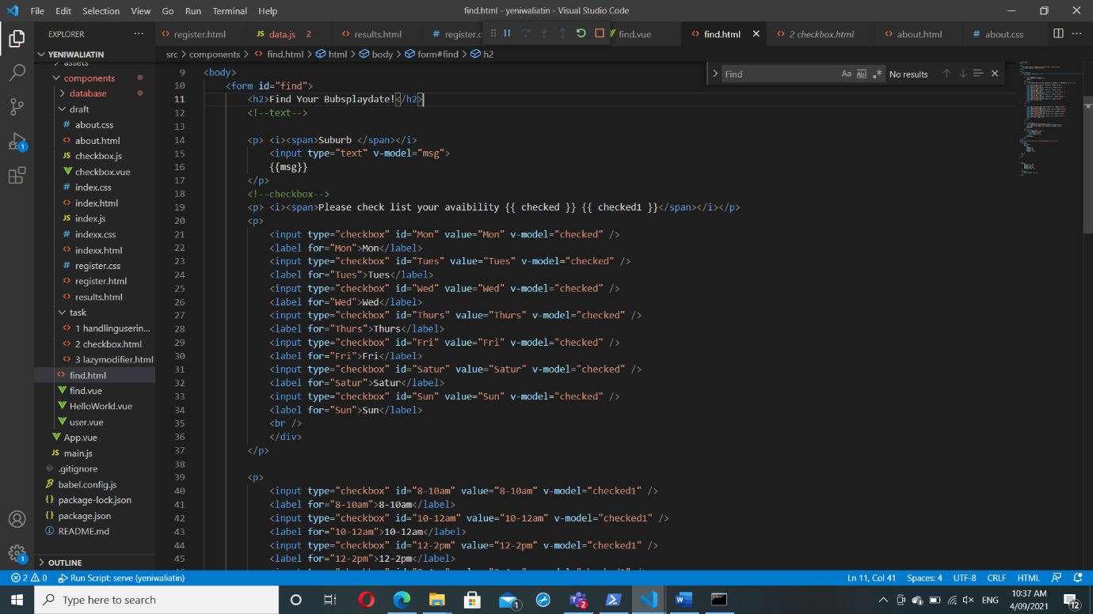

Figure The codes for form input

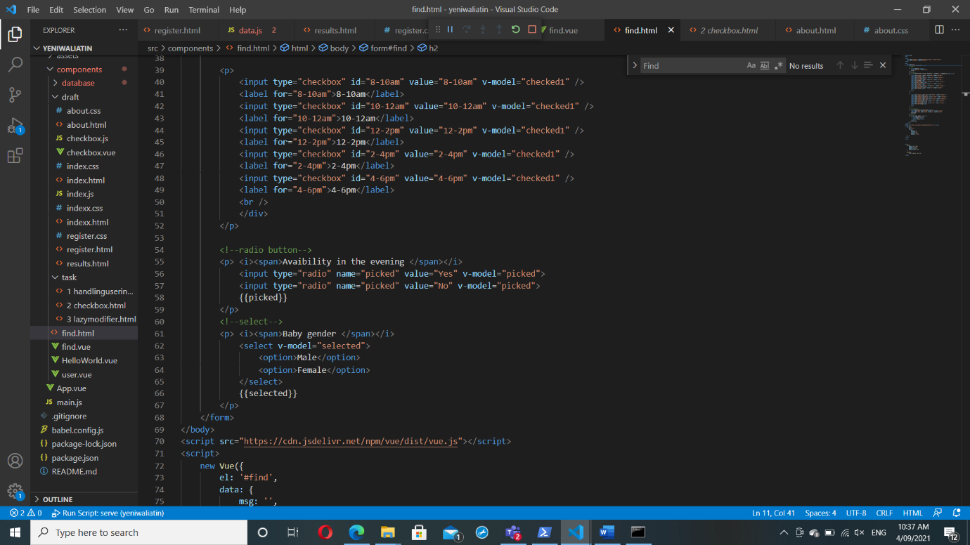

Figure The codes for form input

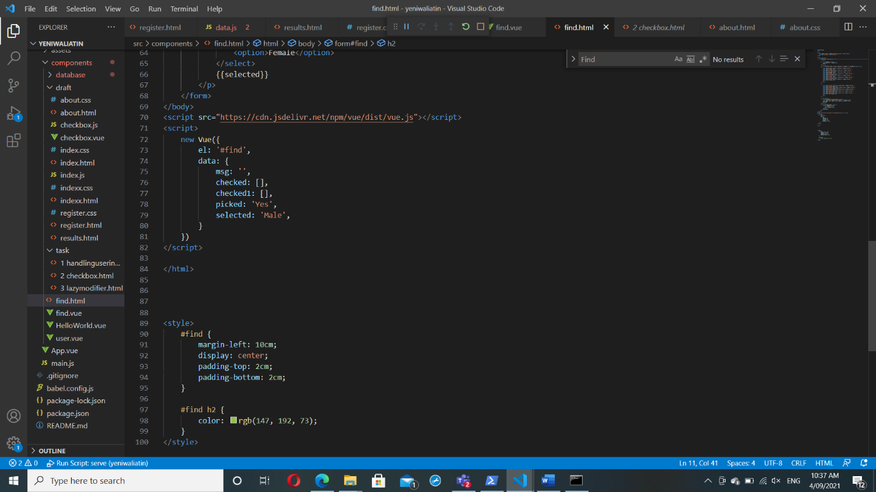

Figure The codes for form input

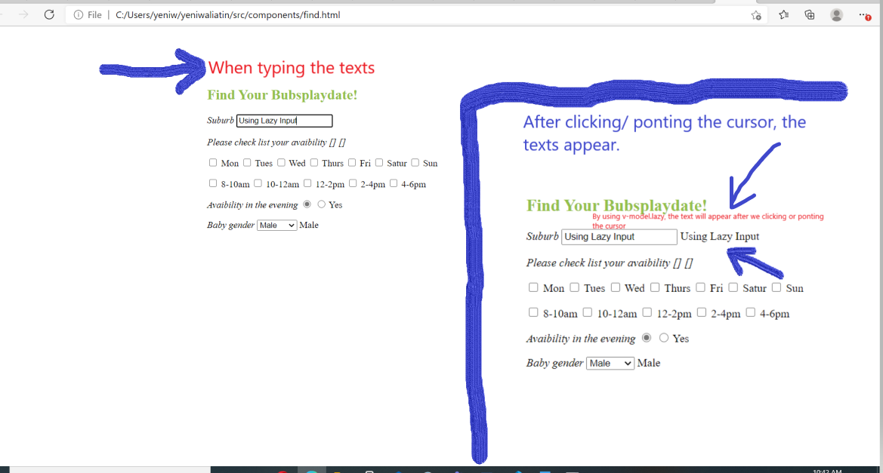

Figure V-model using lazy

## Task Using V-model for handling user inputs

What I have learned here is passing parameter from v-model to Vue script, as screenshot below.

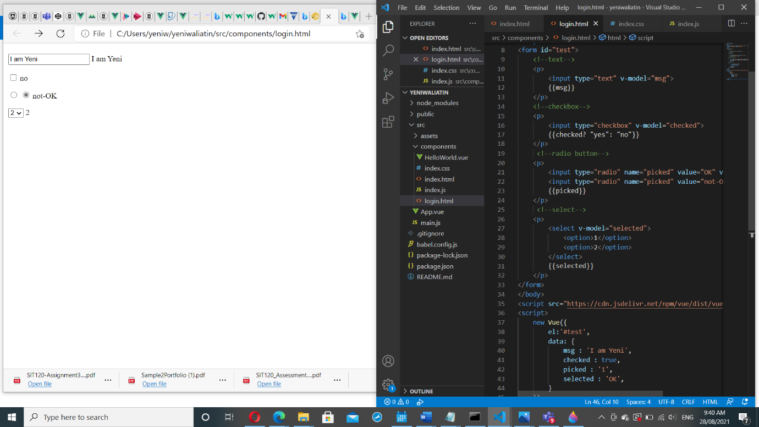

Figure

## Task Checkbox subjects that I have learned so far

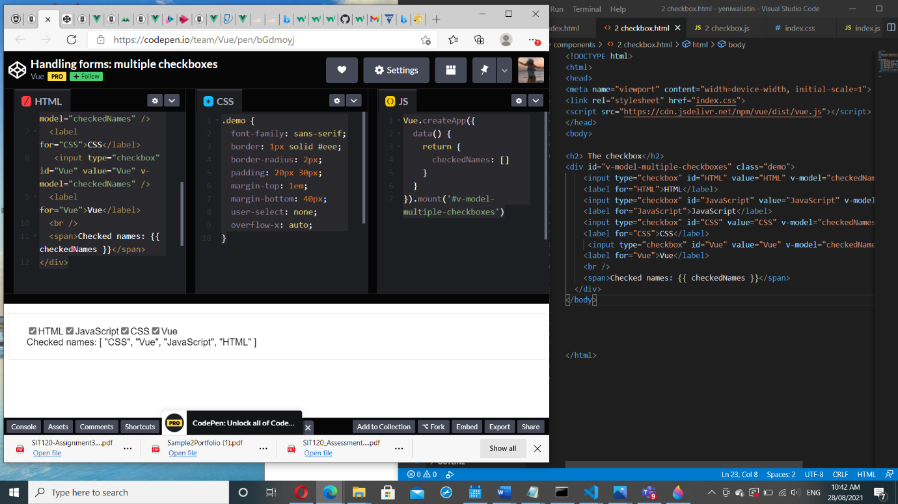

Figure

## Task Dynamic options rendering v-for

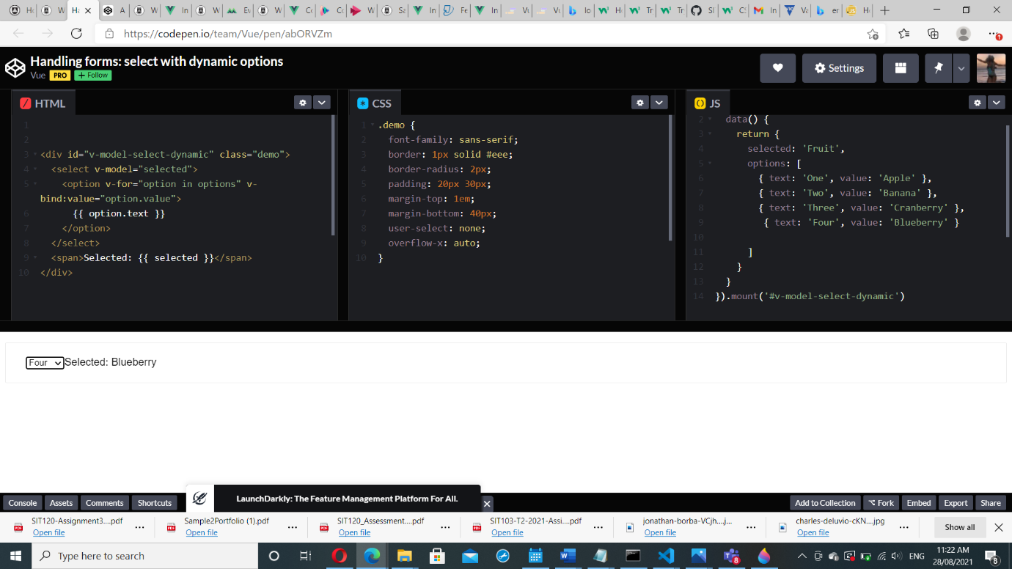

Figure

## Task Using Modifiers (Lazy, Trim, Number)

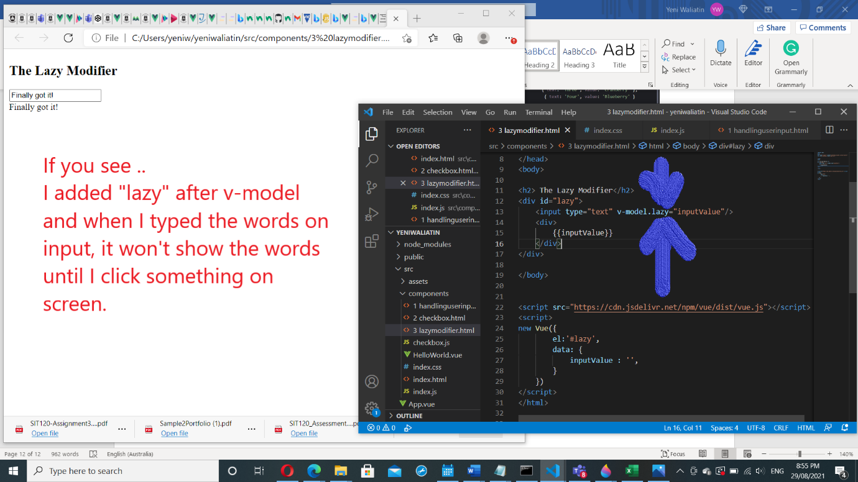

Figure

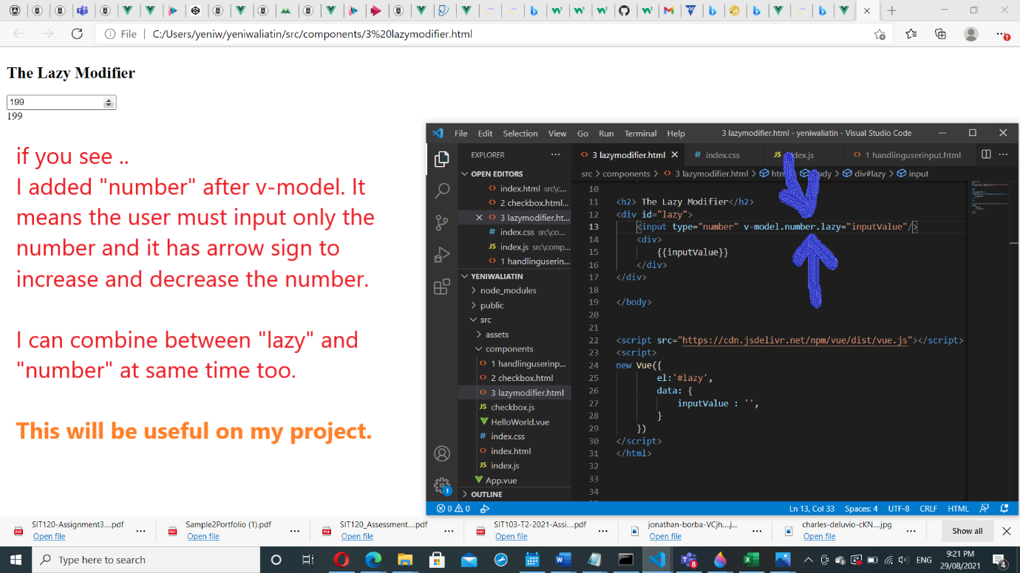

Figure

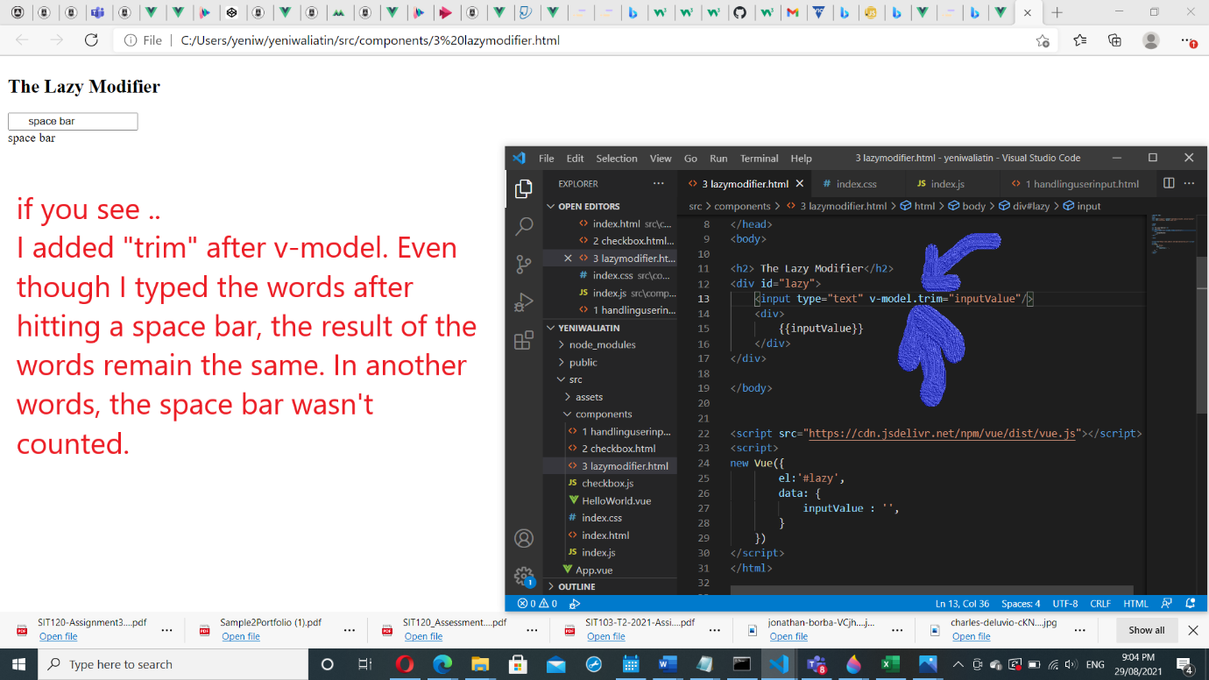

Figure

# Week 7: Vue.js Framework (Handling User Inputs)

## Reflection & github link

I have learned more about [Vue.js framework](https://vuejs.org/v2/guide/forms.html), how to use and apply handling user input, form input bindings, lazy, trim and number modifier also other components which they are so useful for my project, and I have more understanding how HTML, CSS, JavaScript and Vue work together.

Github link: [SIT120/Week6 at main · ywaliatin/SIT120 (github.com)](https://github.com/ywaliatin/SIT120/tree/main/Week6)

## I learned how to import and show data

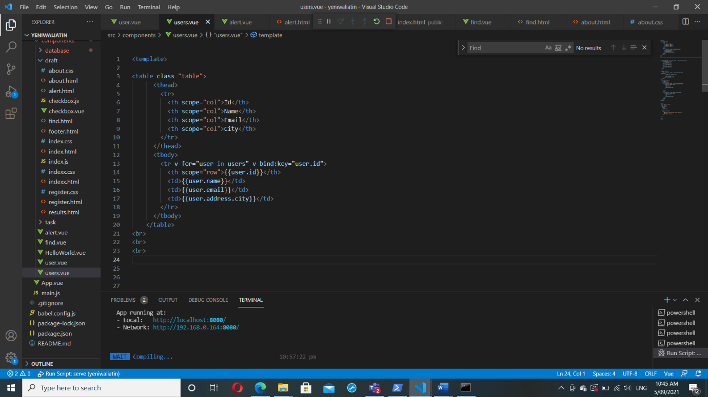

Figure The codes for showing data

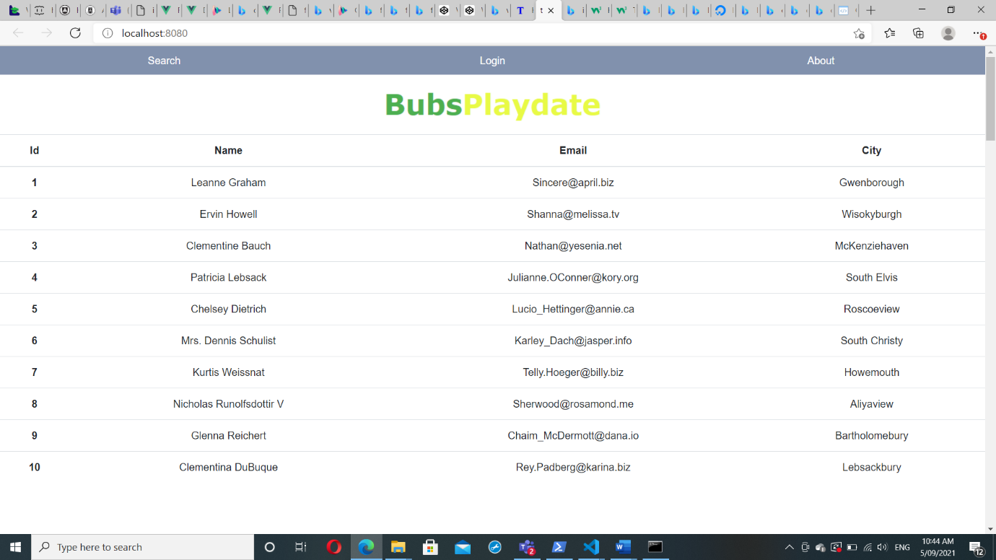

Figure The result

## Important aspect on Vue

One of example is ‘main.vue’ as you seen on *Figure 43.*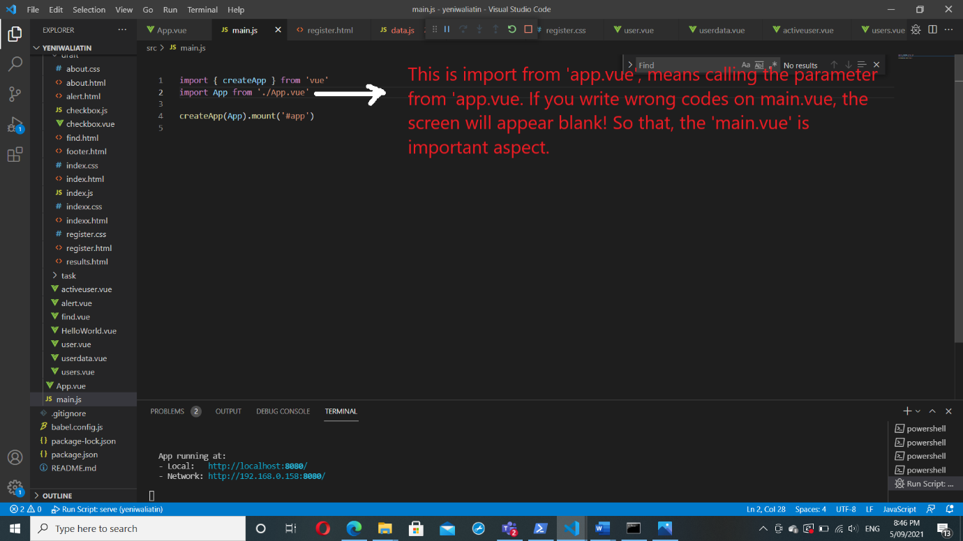

Figure Main.vue

I found an error as you seen on *Figure 44*, and it solved after I have changed the name by using first capital letter [from ‘footer’ to ‘Footer’].

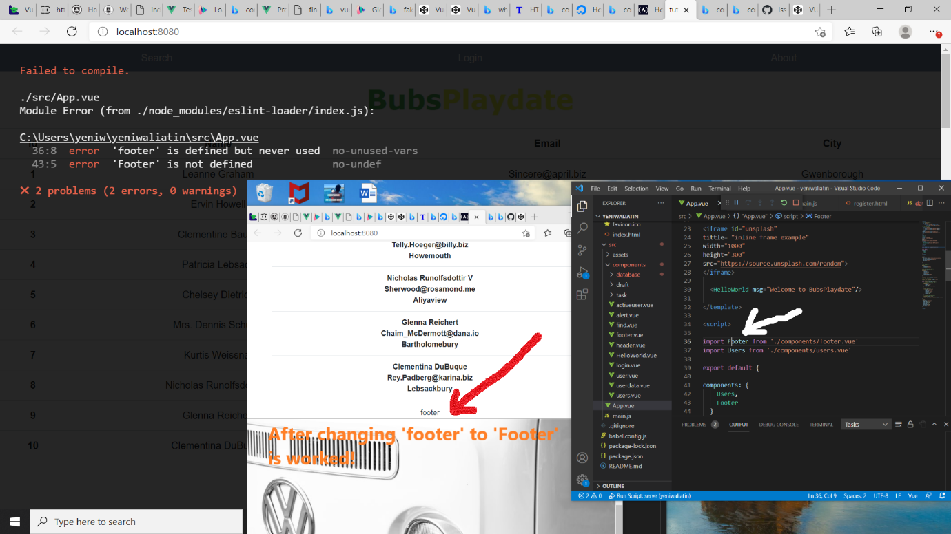

Figure Error Vue

## Project Progress

Here below screenshot of my project progress so far. Github link: [SIT120/Week6 at main · ywaliatin/SIT120 (github.com)](https://github.com/ywaliatin/SIT120/tree/main/Week6)

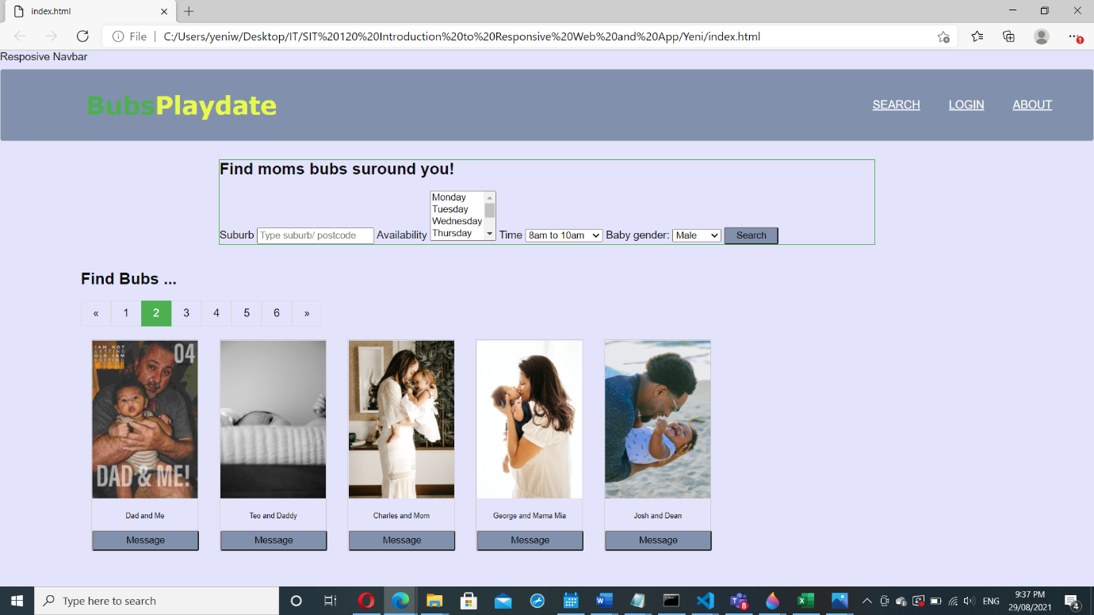

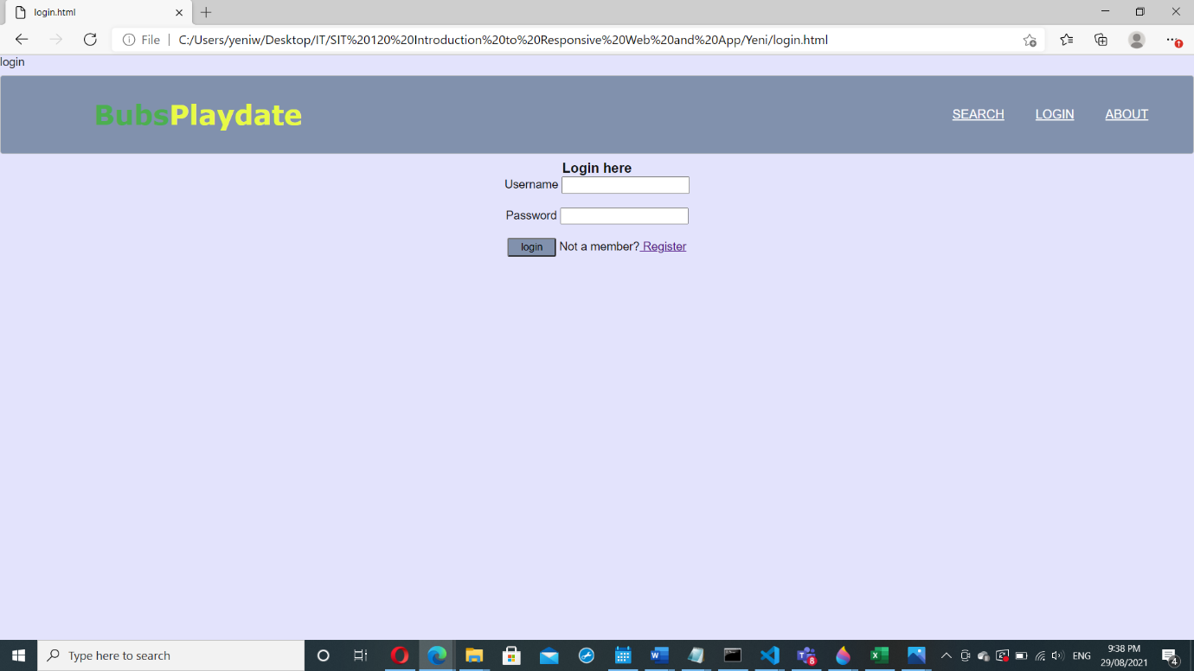

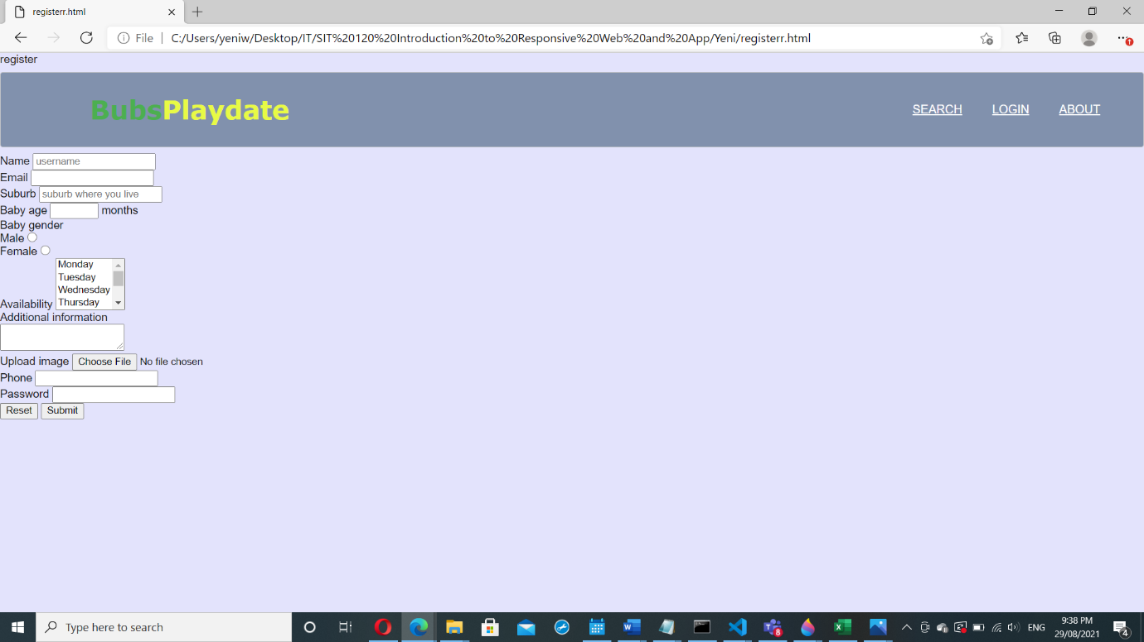

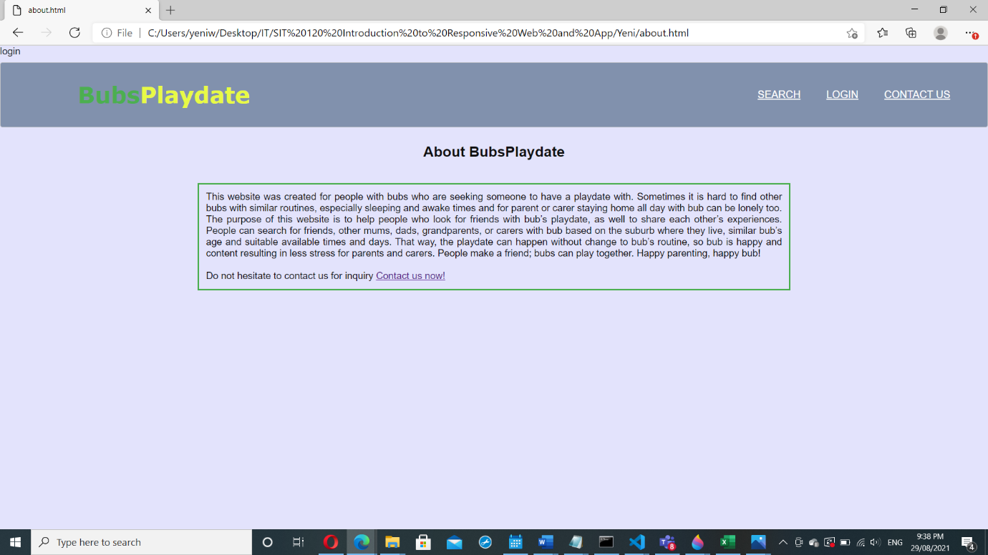

margin

border

padding

content